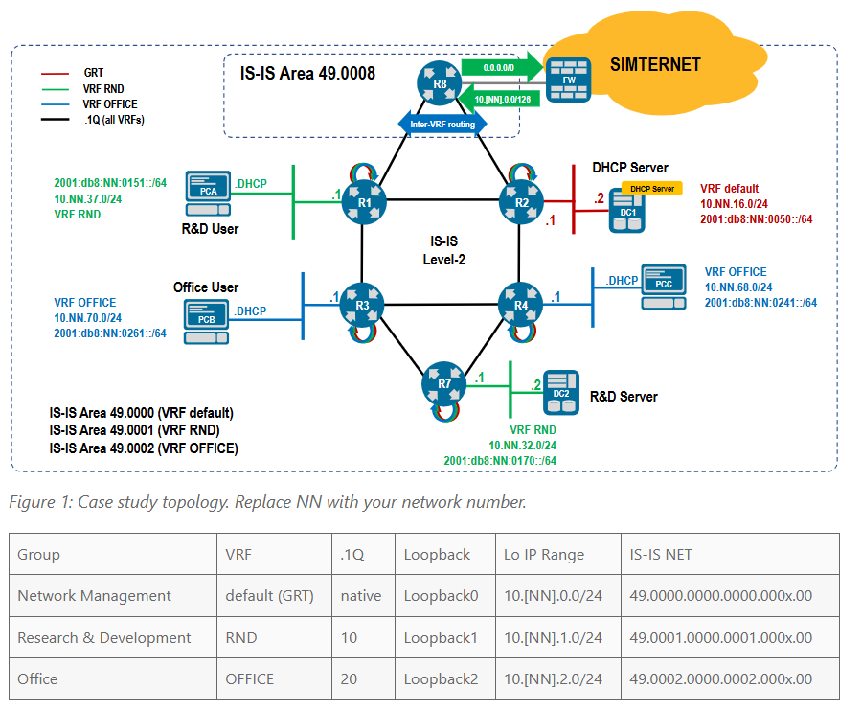
vrf instance OFFICE
!
vrf instance RND
ip routing vrf OFFICE
ip routing vrf RND

interface Loopback1
vrf RND
ip address 10.46.1.1/32
Isis enable RND
!
interface Loopback2
vrf OFFICE
ip address 10.46.2.1/32
Isis enable OFFICE
!
router isis default
no net 49.0000.0046.0001.0001.00
net 49.0000.0046.0000.0001.00

is-type level-2
log-adjacency-changes
!
address-family ipv4 unicast
metric 10000
!
router isis RND vrf RND
net 49.0000.0046.0001.0001.00

is-type level-2
log-adjacency-changes
!
address-family ipv4 unicast
metric 10000

router isis OFFICE vrf OFFICE
net 49.0000.0046.0002.0001.00

is-type level-2
log-adjacency-change
address-family ipv4 unicast
metric 10000

Interface ethernet 1.10
Encapsulation dot1q vlan 10
Vrf RND
Ip address unnumbered loopback1
Isis enable RND
!
Interface ethernet 1.20
Encapsulation dot1q vlan 20
Vrf OFFICE
Ip address unnumbered loopback1
Isis enable OFFICE
!
Interface ethernet 1.30
Encapsulation dot1q vlan 30
Vrf RND
Ip address unnumbered loopback1
Isis enable RND

R2

vrf instance OFFICE
!
vrf instance RND
ip routing vrf OFFICE
ip routing vrf RND

interface Loopback1
vrf RND
ip address 10.46.1.2/32
Isis enable RND
!
interface Loopback2
vrf OFFICE
ip address 10.46.2.2/32
Isis enable OFFICE
!
router isis default
no net 49.0000.0046.0001.0002.00
net 49.0000.0046.0000.0002.00

is-type level-2
log-adjacency-changes
!
address-family ipv4 unicast
metric 10000
!
router isis RND vrf RND
net 49.0000.0046.0001.0002.00

is-type level-2
log-adjacency-changes
!
address-family ipv4 unicast
metric 10000

router isis OFFICE vrf OFFICE
net 49.0000.0046.0002.0002.00

is-type level-2
log-adjacency-change
address-family ipv4 unicast
metric 10000

Interface ethernet 1.10
Encapsulation dot1q vlan 10
Vrf RND
Ip address unnumbered loopback1
Isis enable RND
!
Interface ethernet 1.20
Encapsulation dot1q vlan 20
Vrf OFFICE
Ip address unnumbered loopback1
Isis enable OFFICE
!
Interface ethernet 1.30
Encapsulation dot1q vlan 30
Vrf RND
Ip address unnumbered loopback1
Isis enable RND
!
!
R3
vrf instance OFFICE
!
vrf instance RND
ip routing vrf OFFICE
ip routing vrf RND

interface Loopback1
vrf RND
ip address 10.46.1.3/32
Isis enable RND
!
interface Loopback2
vrf OFFICE
ip address 10.46.2.3/32
Isis enable OFFICE
!
router isis default
no net 49.0000.0046.0001.0003.00
net 49.0000.0046.0000.0003.00

is-type level-2
log-adjacency-changes
!
address-family ipv4 unicast
metric 10000
!
router isis RND vrf RND
net 49.0000.0046.0001.0003.00

is-type level-2
log-adjacency-changes
!
address-family ipv4 unicast
metric 10000

router isis OFFICE vrf OFFICE
net 49.0000.0046.0002.0003.00

is-type level-2
log-adjacency-change
address-family ipv4 unicast
metric 10000

Interface ethernet 1.10
Encapsulation dot1q vlan 10
Vrf RND
Ip address unnumbered loopback1
Isis enable RND
!
Interface ethernet 1.20
Encapsulation dot1q vlan 20
Vrf OFFICE
Ip address unnumbered loopback1
Isis enable OFFICE
!
Interface ethernet 1.30
Encapsulation dot1q vlan 30
Vrf RND
Ip address unnumbered loopback1
Isis enable RND
!
R4
vrf instance OFFICE
!
vrf instance RND
ip routing vrf OFFICE
ip routing vrf RND

interface Loopback1
vrf RND
ip address 10.46.1.4/32
Isis enable RND
!
interface Loopback2
vrf OFFICE
ip address 10.46.2.4/32
Isis enable OFFICE
!
router isis default
no net 49.0000.0046.0001.0003.00
net 49.0000.0046.0000.0003.00

is-type level-2
log-adjacency-changes
!
address-family ipv4 unicast
metric 10000
!
router isis RND vrf RND
net 49.0000.0046.0001.0004.00

is-type level-2
log-adjacency-changes
!
address-family ipv4 unicast
metric 10000

router isis OFFICE vrf OFFICE
net 49.0000.0046.0002.0004.00

is-type level-2
log-adjacency-change
address-family ipv4 unicast
metric 10000

Interface ethernet 1.10
Encapsulation dot1q vlan 10
Vrf RND
Ip address unnumbered loopback1
Isis enable RND
!
Interface ethernet 1.20
Encapsulation dot1q vlan 20
Vrf OFFICE
Ip address unnumbered loopback1
Isis enable OFFICE
!
Interface ethernet 1.30
Encapsulation dot1q vlan 30
Vrf RND
Ip address unnumbered loopback1
Isis enable RND
!

R8
Interface ethernet 1.10
Encapsulation dot1q vlan 10
Vrf RND
Ip address unnumbered loopback0
Isis enable RND
!
Interface ethernet 1.10
Encapsulation dot1q vlan 20
Vrf OFFICE
Ip address unnumbered loopback0
Isis enable OFFICE
!
Interface ethernet 2.20
Encapsulation dot1q vlan 10
Vrf RND
Ip address unnumbered loopback0
Isis enable RND
!
Interface ethernet 2.20
Encapsulation dot1q vlan 20
Vrf OFFICE
Ip address unnumbered loopback0
Isis enable OFFICE

Interface ethernet 2.10
Encapsulation dot1q vlan 10
Vrf RND
Ip address unnumbered loopback0
Isis enable RND
!
Interface ethernet 2.10
Encapsulation dot1q vlan 20
Vrf OFFICE
Ip address unnumbered loopback0
Isis enable OFFICE
!
Interface ethernet 2.20
Encapsulation dot1q vlan 10
Vrf RND
Ip address unnumbered loopback0
Isis enable RND
!
Interface ethernet 2.20
Encapsulation dot1q vlan 20
Vrf OFFICE
Ip address unnumbered loopback0
Isis enable OFFICE

Step 2
r1
Sh run int eth4
Eth4

Vrf RND
Isis enable RND
Lisää ip address
R3
Int eth4
Vrf OFFICE
Isis enable OFFICE
R4
Sh run eth4
Ip dhcp delay information option
Eth4
Vrf OFFICE
Ip address sh run
Isis enable OFFICE

